

FACULTY OF INFORMATION & COMMUNICATION TECHNOLOGY
PROG103 — PRINCIPLES OF STRUCTURED PROGRAMMING
Title : Final Project
Due Date : Week 8
Lecturer/Examiner : Mr. Lavalie
Class : BICT 1201F
Semester : 2/8 Name of Student/s :
NAME | STUDENT.ID | SIGNATURE
Doris Banadette Bockarie | 905005638
Bassam Jaward | 905005929
Kamaludeen Usman | 905005902
Academic Honesty Policy Statement
I/We, hereby attest that contents of this attachment are my own work. Referenced works, articles, art, programs, papers or parts thereof are acknowledged at the end of this paper. This includes data excerpted from CD-ROMs, the Internet, other private networks, and other people’s disk of the computer system
Student’s Signature: Date: 18th /06/2026
LECTURER’S COMMMENTS/GRADE:

Remark
DATE :
TIME:

PRINCIPLES OF STRUCTURED PROGRAMMING FINAL PROJECT

SALES MANAGEMENT SYSTEM
Sustainable Development Goal (SDG 8): Decent Work and Economic Growth

PROJECT RATIONALE

Problem Description
Many small and medium-sized businesses in Sierra Leone still rely on manual methods to manage sales records. Business owners often record transactions in notebooks or paper files, making it difficult to track sales accurately. These traditional methods are time-consuming, prone to human error, and can lead to loss of important information.
Manual record keeping creates several challenges. Business owners may struggle to calculate daily revenue, monitor stock levels, or generate reports needed for decision-making. In addition, misplaced records can result in financial losses and poor business management. These challenges reduce productivity and limit the growth potential of businesses.
To address these problems, our group developed a Sales Management System. The system automates the recording and management of sales information, allowing businesses to store, retrieve, and analyze sales data efficiently. By replacing manual processes with a computerized solution, businesses can improve accuracy, save time, and increase operational efficiency.

System Explanation
The Sales Management System is a Python-based application designed to help businesses manage their sales operations effectively. The system provides a user-friendly interface through which users can perform various sales-related activities.
The system allows users to:
Add new products.
Update product information.
Delete products from the system.
Search for products.
Record sales transactions.
View sales history.
Generate sales reports.
When a user enters product or sales information, the system processes the data and stores it securely. The system automatically calculates totals and provides accurate records for future reference. This reduces errors commonly associated with manual calculations.
The system improves business efficiency by simplifying sales management tasks and providing quick access to important information. It also supports better decision-making through organized sales records and reporting capabilities.

Structured Programming Application
The project was developed using the principles of structured programming. Structured programming promotes organized, readable, and maintainable code through the use of logical structures and modular design.

Variables and Data Types
The system uses variables to store information such as:
Product Name
Product Price
Product Quantity
Total Sales
Different data types are used throughout the system:
String data type for product names.
Integer data type for quantities.
Float data type for prices and sales totals.

Functions
The program is divided into functions to improve code organization and reusability. Examples include:
Add Product Function
Update Product Function
Delete Product Function
Search Product Function
Calculate Sales Function
Functions reduce code repetition and make the system easier to maintain.

Decision Structures
The system uses conditional statements such as:
if elif else
These statements help the system make decisions based on user input and business rules.

Loops
Loops are used to repeat operations efficiently. Examples include:
for loops while loops
Loops allow the system to process multiple records and display information without repeating code unnecessarily.

Modular Programming
The system is organized into separate sections, each responsible for a specific task. This modular approach improves readability, debugging, and future system expansion.
Overall, structured programming principles contributed significantly to the efficiency, reliability, and maintainability of the system.

SDG Relevance
This project supports Sustainable Development Goal 8 (Decent Work and Economic Growth).
SDG 8 aims to promote sustained, inclusive, and sustainable economic growth, productive employment, and decent work opportunities for all.
The Sales Management System contributes to SDG 8 in several ways:

Improving Productivity
The system automates sales management processes, reducing the time required to perform business operations. Increased efficiency allows businesses to focus on growth and customer service.

Supporting Small Businesses
Small and medium-sized enterprises play a significant role in Sierra Leone’s economy. The system helps these businesses improve record management and operational effectiveness.

Reducing Human Errors
Automated calculations and digital records reduce mistakes associated with manual bookkeeping, improving financial accuracy.

Encouraging Digital Transformation
The adoption of software solutions promotes technological advancement within local businesses and prepares them for participation in the digital economy.

Promoting Economic Growth
Efficient business management contributes to increased profitability, improved business sustainability, and overall economic development.
For these reasons, the Sales Management System aligns strongly with SDG 8 and demonstrates how technology can be used to support economic growth and decent work opportunities in Sierra Leone.

GitHub Evidence Section
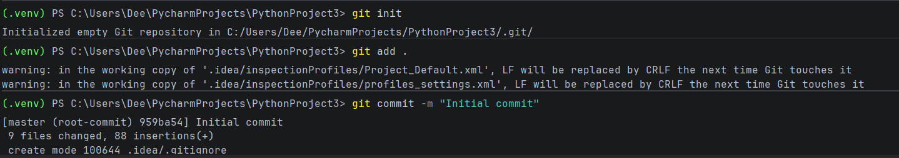

RECIEVER’S NAME:

